Unsupervised Pre-Training

(From Larochelle youtube videos)
Layers are added one at a time and trained with some unsupervised learning algorithm, where the input of the new layer is the output of the net until the last added layer. This training sets the initial values for the parameters for the final net.

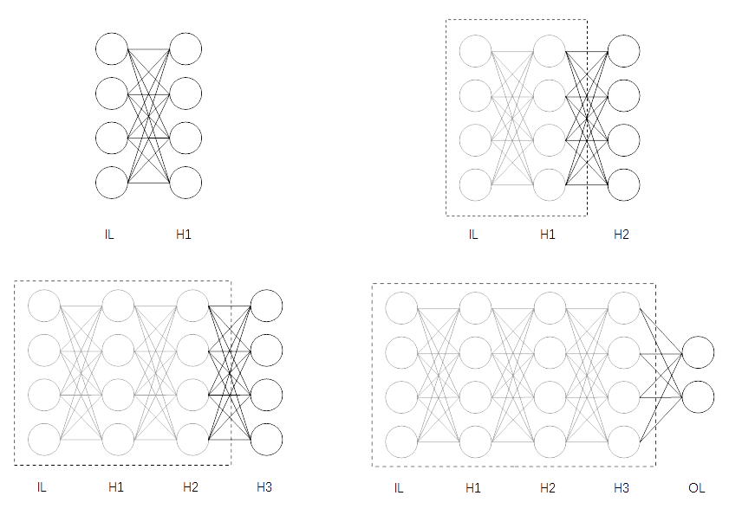
IL stands for Input Layer, H# stands for Hidden Layer #, OL stands for Output Layer.

Then the output layer is added randomly initialized and the normal supervised learning is performed.

This gives the DNN a "headstart" and hopefully it will be initialized near a good minimum.
Unsupervised learning algorithm can be Restricted Boltzmann Machine (RBM), Autoencoders, kernel PCA

Pre-training works as a regularizer: with few hidden units the effects is little (leading to underfitting) but as we increase the width of the layers it leads to better results than without pre-training.
Again: overfits with large capacity, underfits with small capacity

Ref:
- Stacked RBM:
  - A fast learning algorithm for deep belief nets. Hinton, Teh, Osindero, 2006
  - To recognize shapes, first learn to generate images. Hinton, 2006

- Stacked autoencoders:
  - Greedy Layer-Wise Training of Deep Networks. Bengio, Lamblin, Popovici and Larochelle, 2007
  - For sparse autoencoders: Efficient Learning of Sparse Representations with an Energy-Based Model. Ranzato, Pultney, Chopra and LeCun, 2007

